# Module-5

**1. List out the platforms available for Social Media Marketing.**

# Social Media Marketing-

Social media marketing is the use of social media—the platforms on which users build social networks and share information—to build a company's brand, increase sales, and drive website traffic.

# Platforms of Social Media Marketing-

## 1. Facebook –

Facebook is asocial networking sitethat makes it easy for you toconnect and sharewith family and friends online. Originally designed for college students, Facebook was created in 2004 by Mark Zuckerberg while he was enrolled at Harvard University.

## 2. Instagram –

Instagram is a [photo](https://en.wikipedia.org/wiki/Photo_sharing) andvideo sharin[g](https://en.wikipedia.org/wiki/Video_sharing) [social networking service](https://en.wikipedia.org/wiki/Social_networking_service) owned by [Meta Platforms.](https://en.wikipedia.org/wiki/Meta_Platforms) It allows users to upload media that can be edited with [filters,](https://en.wikipedia.org/wiki/Social_media_camera_filter) be organized by [hashtags,](https://en.wikipedia.org/wiki/Hashtag) and be associated with a location via [geographical tagging.](https://en.wikipedia.org/wiki/Geotagging)

## 3. Twitter –

Twitter is a free social networking site where users broadcast short posts known as tweets. These tweets can contain text, videos, photos or links.

## 4. LinkedIn –

LinkedIn is the world's largest professional network on the internet. You can use LinkedIn to find the right job or internship, connect and strengthen professional relationships, and learn the skills you need to succeed in your career.

## 5. Pinterest –

Pinterest is a visual discovery engine for finding ideas like recipes, home and style inspiration, and more.

**2. How many types of content we can use for Social Media Marketing? Explain any three.**

There are 5 types of content we can use for social media marketing:

* **Entertainment**
* **Education**
* **Inspiration**
* **Conversation**
* **Promotion**

## 1. Live video-

Many platforms have livestream capabilities, but the best ones are Facebook Live, Instagram Live, YouTube Live and LinkedIn Live.37% of consumers find live video the most engaging type of social media content. It enables businesses and creators to broadcast conversations, webinars, Q&As or other virtual events. And unlike [text or image posts,](https://sproutsocial.com/insights/static-posts/) where you wait for an interaction, live videos give audiences a chance to react in real time.

## 2. Images-

* Photos: Visual content is a powerful way to communicate, often shared on Instagram, Facebook, and Twitter. It can range from personal snapshots to professional photography.
* Memes: Humorous or culturally relevant images combined with text, widely shared for entertainment.
* Infographics: Visual representations of data or information, used for educational or promotional purposes.

## 3. GIFs/memes-

GIFS and memes are a particular type of social media content favored by younger generations. When words can’t describe the mix of gestures and feelings we all relate to at some point, memes can add meaning to these situations.

## 4. Text-based posts-

It’s important for businesses to prioritize visual content, but they shouldn’t lose sight of the power of words. What’s more, 32% of consumers say text-based posts are still one of the most engaging types of social media content.

Written content needs the same attention, consistency and creative elements that you give other content formats. But developing a distinctive [brjkand tone and voice](https://sproutsocial.com/insights/brand-voice/) that aligns with your visual identity will help your written content stand out from the crowded social chatter.

### 5. Audio-

Social audio is about using your voice rather than comments, emojis or reactions to communicate. You record yourself talking about hot topics or experiences you think will interest your audience. And the single best format for this type of social media content is podcasts.

### 6. URL/links to other content-

Using links helps you bring more followers to your website or other content. As the links are in your social media posts, it gives your audience easy access to content of interest and extends their experience with your brand.

URLs allow your brand to share more details, or go beyond the limits of character count within a social media platform with a single click.

**3. Why should we use Social Media**

**Marketing to promote our business?**

We use Social Media Marketing to promote our business Because-

### 1. Improve your brand-

* Social media marketing can have a positive impact on your brand. It can help humanize your company while building trust, loyalty, authority, and recognition.
* By posting content that shows the people behind your brand as well as real users of your product, you can build brand credibility and trustworthiness.

### 2. Engage the audience-

▪ Social media is not only a good way to grow brand awareness, but it also offers companies the chance to engage, respond to posts, share user-generated content, and follow up with dissatisfied customers. Unlike traditional media like radio, television, newspapers, and magazines, social media allows customers and businesses to interact.

### 3. Promote customer service-

* Your company may already have chat, email, and phone lines dedicated to serving your customers, but social media is another great way to connect. Additionally, since the criticism you receive over social media is very public by nature, a well-timed and thoughtful reply shows your broader audience that you’re listening to feedback and responding.
* Providing a resolution to an upset customer not only increases the chance of that customer shopping with your company again — it also shows other consumers the type of service you offer, building trust and loyalty.

### 4. Website traffic-

• Social media can drive traffic to your website, where customers can make purchases or fill out forms.

#### 5. Cost-effective-

• Social media marketing can be cost-effective, especially if you post content organically.

#### 6. Competitor analysis-

• Analyzing your competitors on social media can help you understand their strengths and weaknesses and stay ahead of them.

#### 7. Conversion rates-

• Social media marketing can help increase conversion rates.

### 8. Leveraging trends-

• You can create content that plugs into relevant trends to capture new audiences and ensure your brand's virality.

**4. What is the relationship between**

**SEO and Social Media Marketing**

SEO stands for search engine optimization. It’s the practice of optimizing web pages to rank well in search engine results.

Social media marketing involves publishing or advertising on platforms like Facebook, Twitter, Instagram, Snapchat, WeChat, TikTok, and YouTube.

**Relationship between SEO and Social Media**

**Marketing-**

#### 1. Increased Visibility and Traffic-

Social media can amplify content that is already optimized for SEO. When content is shared on social platforms, it increases the chances of getting more traffic, which may lead to more backlinks and, ultimately, better SEO rankings.

#### 2. User Engagement and Dwell Time-

Engaging social media content can bring in more engaged users, which can positively impact the site’s SEO metrics like bounce rate and dwell time.

#### 3. Brand Awareness and Reputation-

The more well-known and trusted a brand is on social media, the more likely it is to be searched on Google, which can improve SEO rankings due to branded search queries.

#### 4. Content Distribution-

High-quality content that ranks well in search engines can be shared on social media, generating more engagement and further improving its SEO performance through shares, likes, and mentions.

#### 5. Link Building and Social Signals-

Social signals (such as likes, shares, and mentions) might not directly affect SEO rankings, but they can contribute to increased visibility and engagement, leading to more inbound links and improved SEO.

#### 6. Local SEO and Social Media-

Consistent social media activity, combined with local SEO efforts (such as Google My Business optimization), can help build a local audience, which is essential for businesses targeting local markets.

**5. Prepare a word file in which you should add:**

* **Type of content to create on YouTube for**

**http://www.designer2developer.com**

* **Suitable topic list for**

**http://www.designer2developer.com**

**according to your research on Google trends o List out the points to include in the video o Suitable title and description for the video o Keywords to target and its placement**

This site is not working………

**6.What are tools we can use for Marketing on a platform like Facebook and Instagram?**

#### 1. Meta Business Suite-

* Manage your Facebook and Instagram accounts from a single platform.
* Create, schedule, and manage posts across Facebook and Instagram
* Access performance metrics, including reach, engagement, and more
* Unified inbox for managing messages and comments

#### 2. Facebook Pixel-

* Track user behavior on your website and optimize Facebook and Instagram ads.
* Conversion tracking (e.g., purchases, leads, form submissions)
* Retargeting (reaching people who have visited your site but didn’t convert)
* Lookalike audiences (targeting people similar to your best customers)

#### 3. Hootsuite-

Hootsuite is a [social media](https://www.techtarget.com/whatis/definition/social-media) management platform that helps organizations deliver enhanced social media experiences to their customers at every stage of the customer journey. The [platform](https://www.techtarget.com/searchitoperations/definition/platform) includes numerous features to manage social media channels; create content; and plan, schedule and optimize social media interactions.

#### 4. Audience Insights-

* Research and analyze Facebook's user data to better understand your audience and plan your marketing strategies.
* Detailed demographic breakdown (age, gender, location)
* Interests, behaviors, and purchasing patterns
* Competitive analysis of similar audiences

#### 5. Facebook Ads Manager-

* Create, manage, and analyze advertising campaigns across both Facebook and Instagram.
* Audience targeting (location, interests, demographics, etc.)
* Ad types (image, video, carousel, stories, and more)
* Budgeting and bidding options

#### 6. Creator Studio-

* Manage content and track performance on both Facebook and Instagram from one central dashboard. • Schedule posts, videos, and IGTV content
* Insights on engagement, audience demographics, and post performance

#### 7. Audience Insights-

• Research and analyze Facebook's user data to better understand your audience and plan your marketing strategies.

#### 8. Hashtagify-

• Hashtagify is a tool that helps users find and analyze hashtags for social media posts and photos.

**7. What type of traffic you will get on platform like Linked-In?**

[LinkedIn](https://www.entrepreneur.com/topic/linkedin) is perhaps the premier networking platform for professionals and business owners, but there are great ways to make it pay additional dividends.

**There are 7 ways to Drive Traffic from LinkedIn to Your Website:**

#### 1. Create a profile that attracts-

• An engaging LinkedIn profile is a pivotal first consideration, but you don't need to do anything terribly complex to draw attention. You do, however, need to cover the basics. In general, a winning profile contains a clean and presentable headshot, a brief introduction of what you do, and a concise and straight-to-the-point history of work experience.

#### 2. Acquire more connections-

* Another way to boost website traffic from your profile is by creating more connections, precisely the first-degree variety (people you choose to accept as a connection or friend). Having more doesn't just expand your network on the platform, but it also increases the chances of driving people to your website.
* The goal should be to start with at least 500 first-degree connections, then continue building from there by personalizing connection requests, exploring various [LinkedIn groups](https://www.entrepreneur.com/topic/linkedin-groups) and engaging more with your current network of connections.

#### 3. Join relevant groups-

• Another way you can drive traffic from your LinkedIn profile is by joining relevant groups. Not only can you use these to build and gain more connections, you can also post your content there to entice target audiences to visit your site and so gain access to more content.

#### 4. Create a group-

• In addition to joining groups, you can also create your own — the advantages of which include establishing yourself as an expert in an industry; the more people who join your group, the broader your reach (and so driven traffic) will be. Keep in mind that managing your own LinkedIn group comes with responsibilities, such as constantly engaging with an audience. You can do this by regularly posting content, asking questions and commenting on posts.

#### 5. Make frequent updates-

• LinkedIn is similar to popular [social media](https://www.entrepreneur.com/science-technology/social-media) sites like [Facebook](https://www.entrepreneur.com/topic/facebook) and [Twitter:](https://www.entrepreneur.com/topic/twitter) Although it has a slightly different target audience, one shared principle is that if driving more traffic is the goal, you need to offer an audience a steady stream of engaging content. Sharing new content (perhaps including images, videos, and other striking elements) at least once a day can effectively keep an audience's attention and entice them to visit your site for more.

#### 6. Create engaging headlines for links-

* Another proven traffic driver is engaging titles for links that pique curiosity and interest. For example, instead of a link simply called "My [Blog,](https://www.entrepreneur.com/topic/blog)" consider something like "Boost Your Page Rankings with These X Tips" or "Top X Ways to Increase Your Website's Traffic".
* Titles should be simple and concise, appeal to what a target audience is looking for, and should effectively summarize what they will get by clicking.

#### 7. Add an RSS feed-

• Did you know that you can also display your blog's latest posts on LinkedIn, and add integrations to a profile to improve its overall functionality? One great improvement is the addition of a Really Simple Syndication (RSS) feed that displays the last couple of posts you published on your website's blog.

1. **Create social media presence (page or account) which helps your website and blog.**

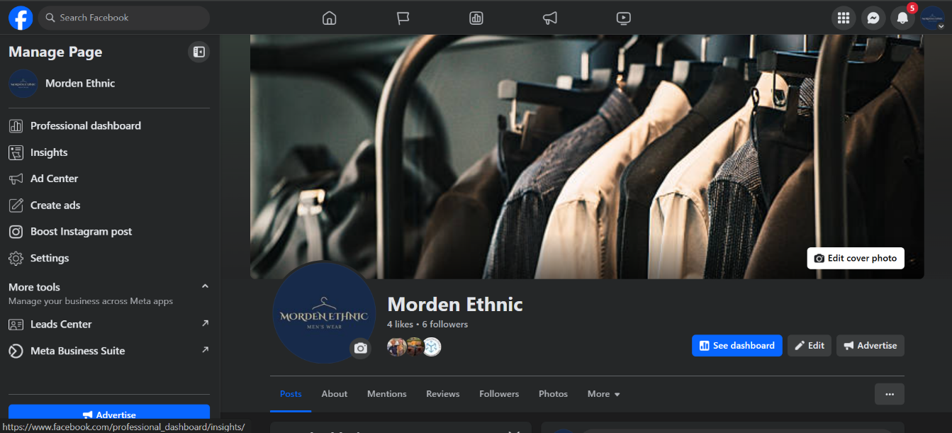

1. **Prepare an excel sheet for posts of www.esellerhub.com to publish on Facebook, Instagram and Linked**

**In.**

Excel Sheet will uploaded…

**Meta business suite schedule post-**

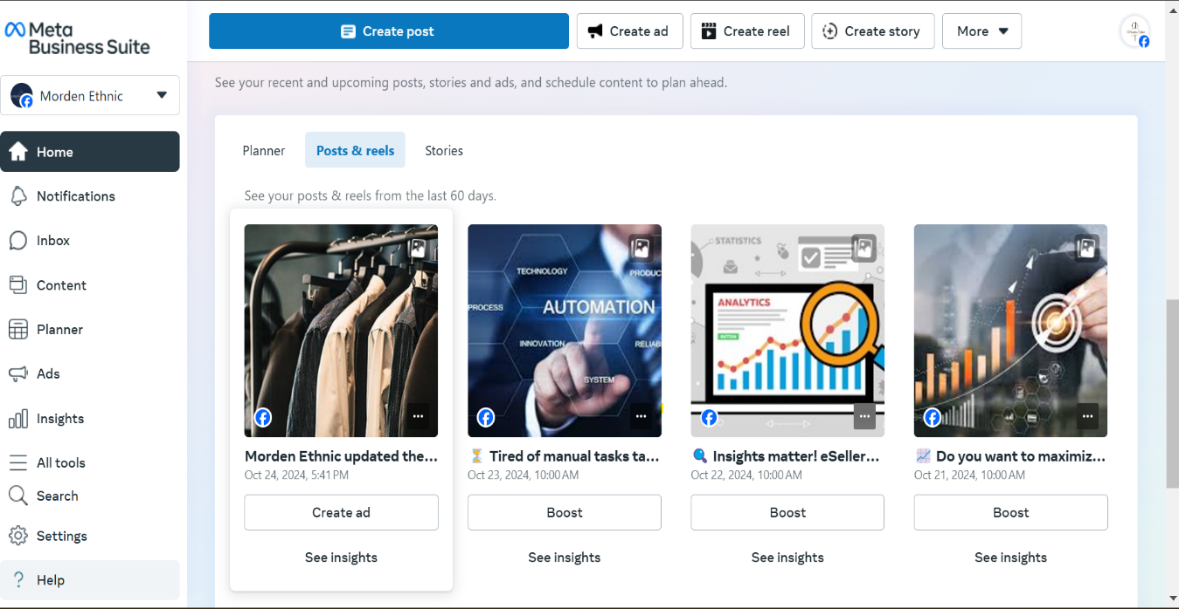

1. **What is the use of E-mail marketing?**

Email marketing is a powerful tool for businesses to engage with their audience, build relationships, and drive sales.

# Use of E-mail marketing-

## 1. Customer Engagement & Retention-

Regular emails keep your audience engaged with your brand. They can include newsletters, updates, or exclusive offers, helping maintain interest and loyalty.

## 2. Brand Awareness-

Email marketing helps reinforce brand identity and recognition by consistently presenting brand messaging and values.

## 3. Cost-Effective Marketing-

Compared to traditional marketing channels, email marketing is relatively inexpensive while offering a high return on investment (ROI).

## 4. Performance Tracking-

With analytics, businesses can track the success of their campaigns through open rates, click-through rates, and conversions, allowing for continual optimization.

## 5. Promotions & Sales-

Businesses often use email marketing to promote new products, services, or special deals, directly reaching customers with targeted offers.

## 6. Direct Traffic to Website-

Email campaigns can drive traffic to websites, encouraging customers to explore products, services, or content.

**11. What goals you can achieve with the help of email marketing?**

## 1. Define your objectives for email marketing-

Aligning email marketing goals with broader business objectives ensures email marketing efforts align with their overall strategies and goals. By doing so, companies can maximize the impact of their campaigns and contribute directly to the bottom line.

Whether the goal is to increase sales, drive website traffic, or boost brand awareness, it's essential to prioritize goals that align with the business's unique needs and priorities. This ensures that every email sent serves a purpose and contributes to the larger organizational goals.

## 2. Set specific and measurable goals-

Businesses should define actionable, quantifiable, and timebound goals to provide clarity and direction for their email marketing efforts. Setting benchmarks and key performance indicators allows businesses to track progress, measure success, and course-correct if necessary.

## 3. Align your goals with audience segmentation and personalization-

Use customer data to segment your target audience. By segmenting audiences based on demographics, behavior, or preferences, businesses can tailor their content and messaging to resonate with specific types of customers. This increases the relevance of the emails and enhances customer engagement and conversions.

## 4. Establish realistic timeframes and expectations-

Industry trends, seasonality, or audience growth rates can influence progress toward email marketing goals. Businesses should consider these factors when setting timelines and expectations, ensuring that they allow for enough time to see meaningful results.

## 5. Monitor and evaluate your progress-

Businesses should prioritize tracking key metrics and performance indicators to gauge the effectiveness of their email marketing efforts. By regularly reviewing analytics and reports, businesses can identify trends, uncover opportunities, and pinpoint areas for improvement.

## 6. Adjust strategies based on performance-

Companies must be open to adjusting their digital marketing strategies based on performance data and insights gathered from monitoring and evaluation efforts. Whether tweaking subject lines, refining audience segmentation, or experimenting with different types of content, businesses can optimize their email marketing campaigns for better results.

1. **Create Sign-up / Subscriber popup form for your blog and website using email marketing tools to collect audience data.**

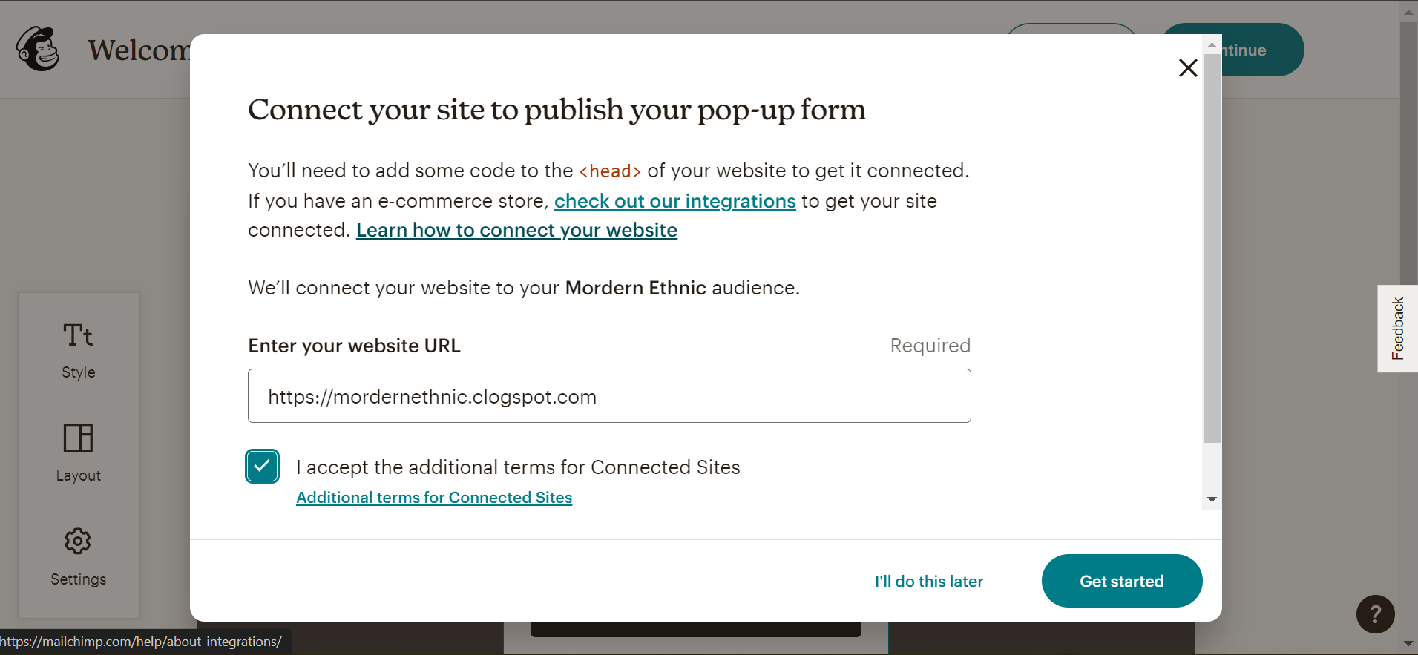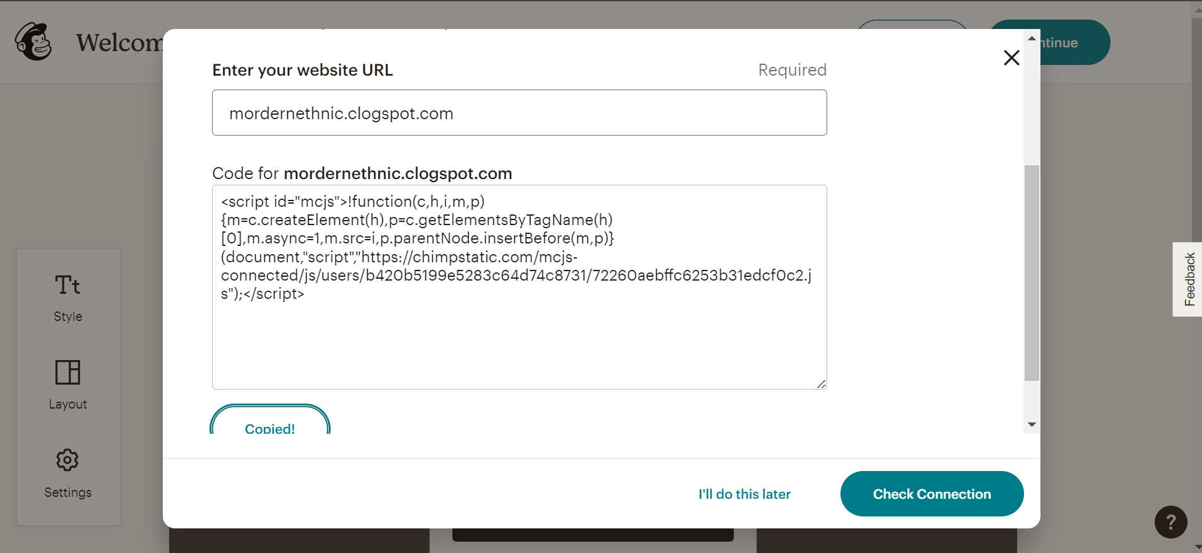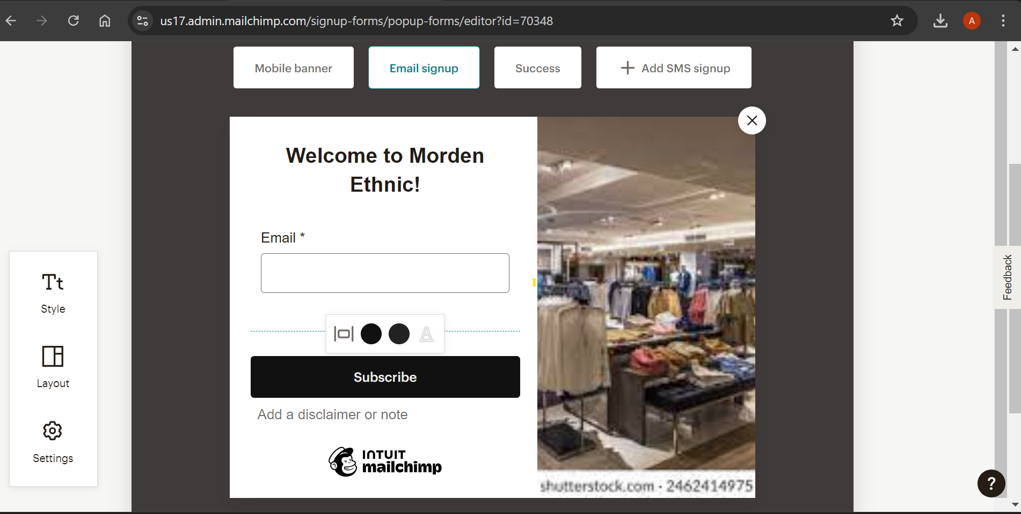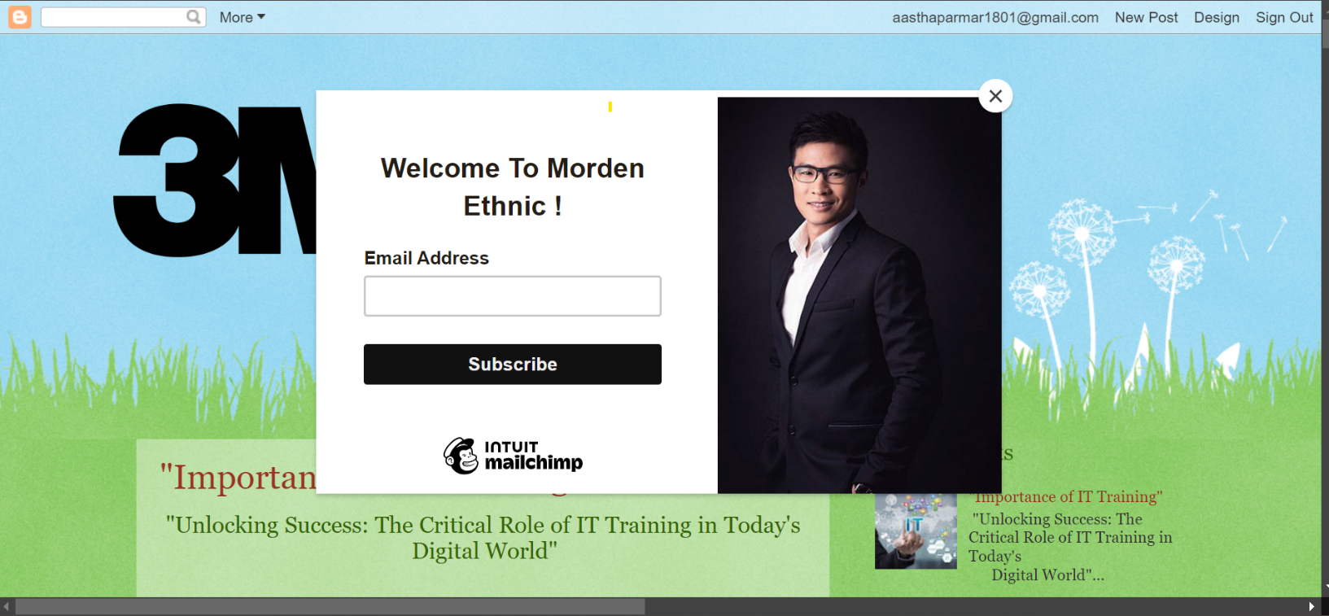

1. **What is affiliate Marketing?**

* + Affiliate marketing is a type of performance-based marketing in which a business rewards one or more affiliates for each visitor or customer brought by the affiliate'sown marketing efforts.

* + Affiliate marketing is one of the oldest forms of marketing wherein you refer someone to any online product and when that person buys the product based on your recommendation, you receive a commission.

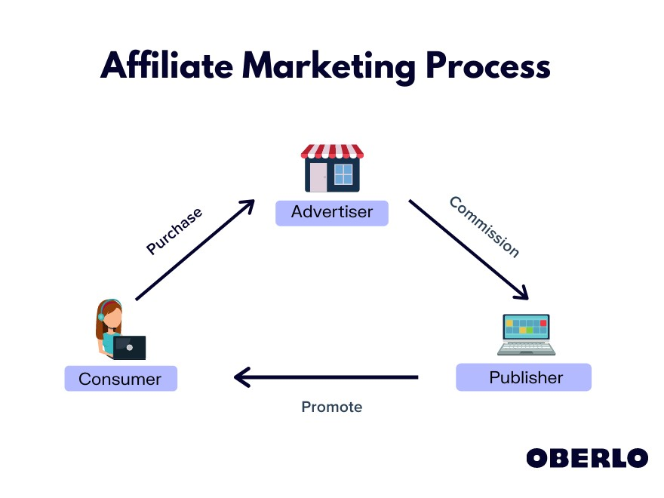

**15.List some famous websites available for affiliate marketing.**

## 1. Amazon Associates-

* One of the largest affiliate programs worldwide.
* Affiliates can promote products from the entire Amazon marketplace.

## 2. Shopify Affiliate Program-

* Allows affiliates to earn commissions by promoting

Shopify’s eCommerce platform.

* Targets entrepreneurs and small businesses.

## 3. Bluehost Affiliate Program-

* A web hosting affiliate program with generous commissions.
* Popular among bloggers and website owners.

## 4. ShareASale-

* An established affiliate network with a wide variety of merchants and products.
* Includes numerous niches such as fashion, home goods, and tech.

## 5. CJ Affiliate (formerly Commission Junction)-

* One of the oldest and most reputable affiliate marketing networks.
* Partners with major brands like Overstock, GoPro, and more.

## 6. eBay Partner Network-

• eBay’s affiliate program where marketers can earn commissions by promoting eBay listings.

## 7. ClickBank-

* Focuses primarily on digital products, such as eBooks, courses, and software.
* Popular among those promoting info products.

## 8. FlexOffers-

* A large network offering affiliate programs in various categories.
* Known for having thousands of advertiser partners.

**16.** **Which are the platforms you can use for affiliate marketing?**

1. **Bluehost-** A web hosting company with a popular affiliate program, particularly for bloggers and webmasters.
2. **Shopify**- Offers commissions for referring new customers to their eCommerce platform.
3. **Target Affiliate Program**- Lets affiliates promote products from the popular retail giant.
4. **eBay Partner Network**- Allows affiliates to promote products listed on eBay and earn commissions on sales.
5. **YouTube**- Create video reviews, tutorials, or unboxings and include affiliate links in the description.
6. **Instagram**- Influencers and content creators can use affiliate links in their bio or Instagram stories.
7. **TikTok**- Short video content with product reviews or recommendations, including affiliate links in profiles.

## 8. Blogging Platforms (WordPress, Wix,

**Medium)**- Perfect for embedding affiliate links into blog posts, product reviews, and content.

1. **Pinterest**- Affiliate marketers can share pins that link to blog posts or directly to affiliate products.
2. **Facebook**- Groups, pages, and posts can include affiliate links to recommended products.
3. **Twitter**- Short, engaging tweets with affiliate links to products or services.
4. **LinkedIn**- Professionals can share product or service recommendations and affiliate links in posts or articles.

## 13. Email Marketing Platforms-

* Mailchimp
* ConvertKit
* AWeber
* GetResponse